**Moderate to Severe Evaluation**

Sample_id :**JRF6CP** **(Dog)**

Link:<https://release.animalbiome.com/pet/assessment/report/appendix/d476e3bf-ebbc-46ba-ba6b-8ee993d25302>

Cats and dogs:

Any two of the following:

(

High Red Flag Megamonas OR (failed)

High Red Flag Sutterella OR (failed)

High Red Flag Collinsella OR (failed)

Low Red Flag Bacteroides OR (**passed**)

Low Red Flag Blautia (failed)

);

OR

Dogs:

8 or more yellow flags (failed)

OR 8 or more red flags (failed)

High red megamonas,suttrella failed.

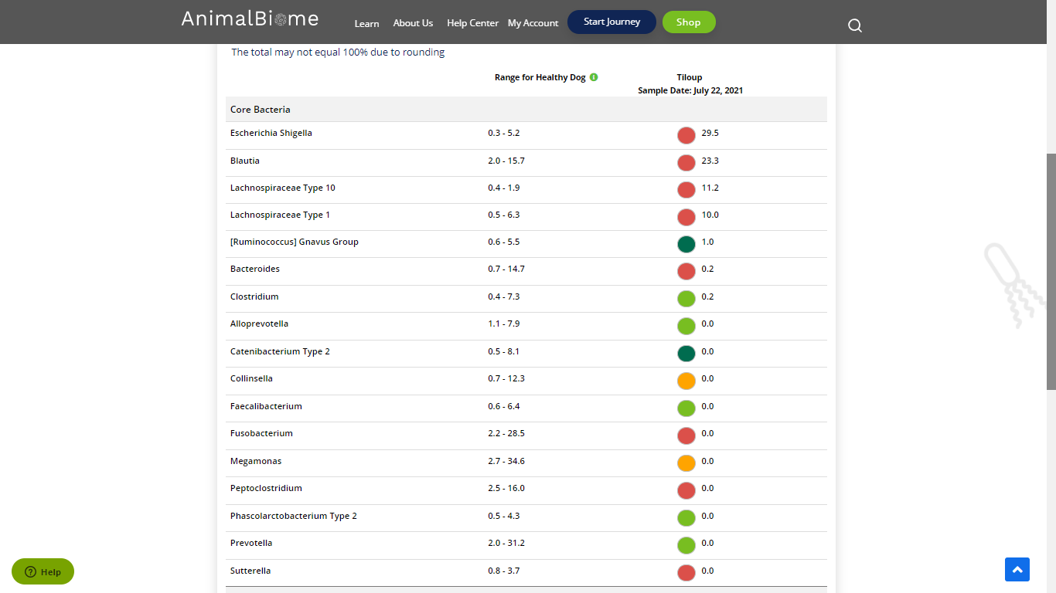

Low group evaluation:

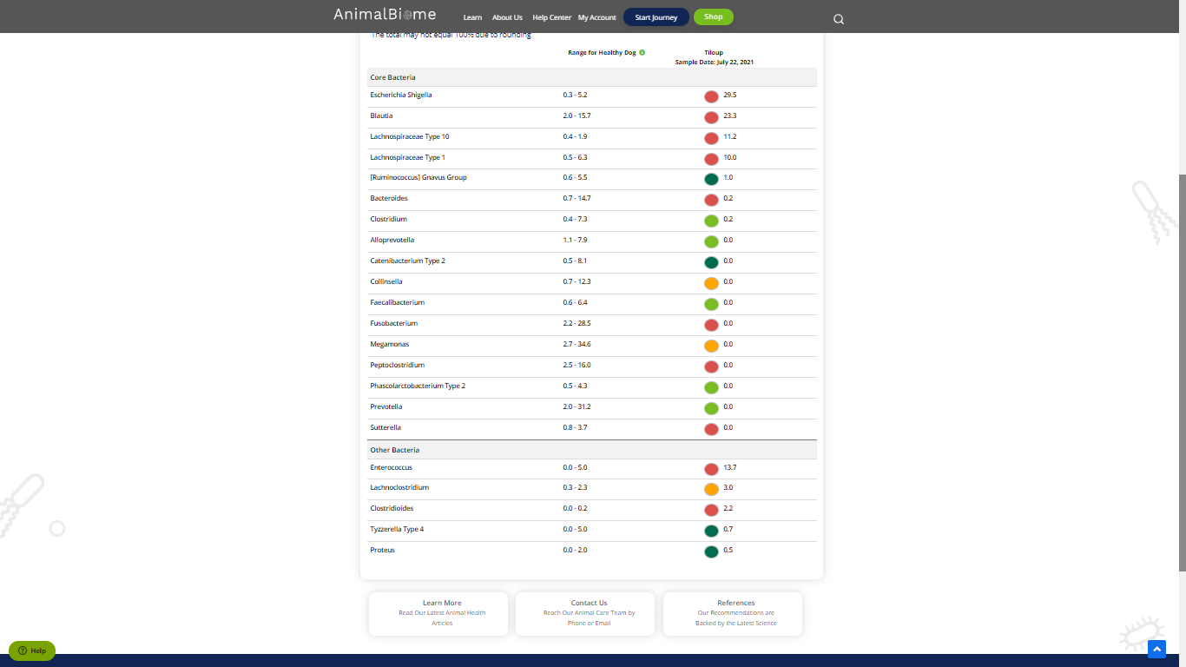

low red blautia : failed

Low red bacteroides : **passed** (only one condition satisfied ) in the primary group.

Total yellow flags : 3

Red flags : 10

The result : **False False True**

Moderate to severe results:Pass

Expected result :  **Moderate to severe**

Achieved result : **passed.**

